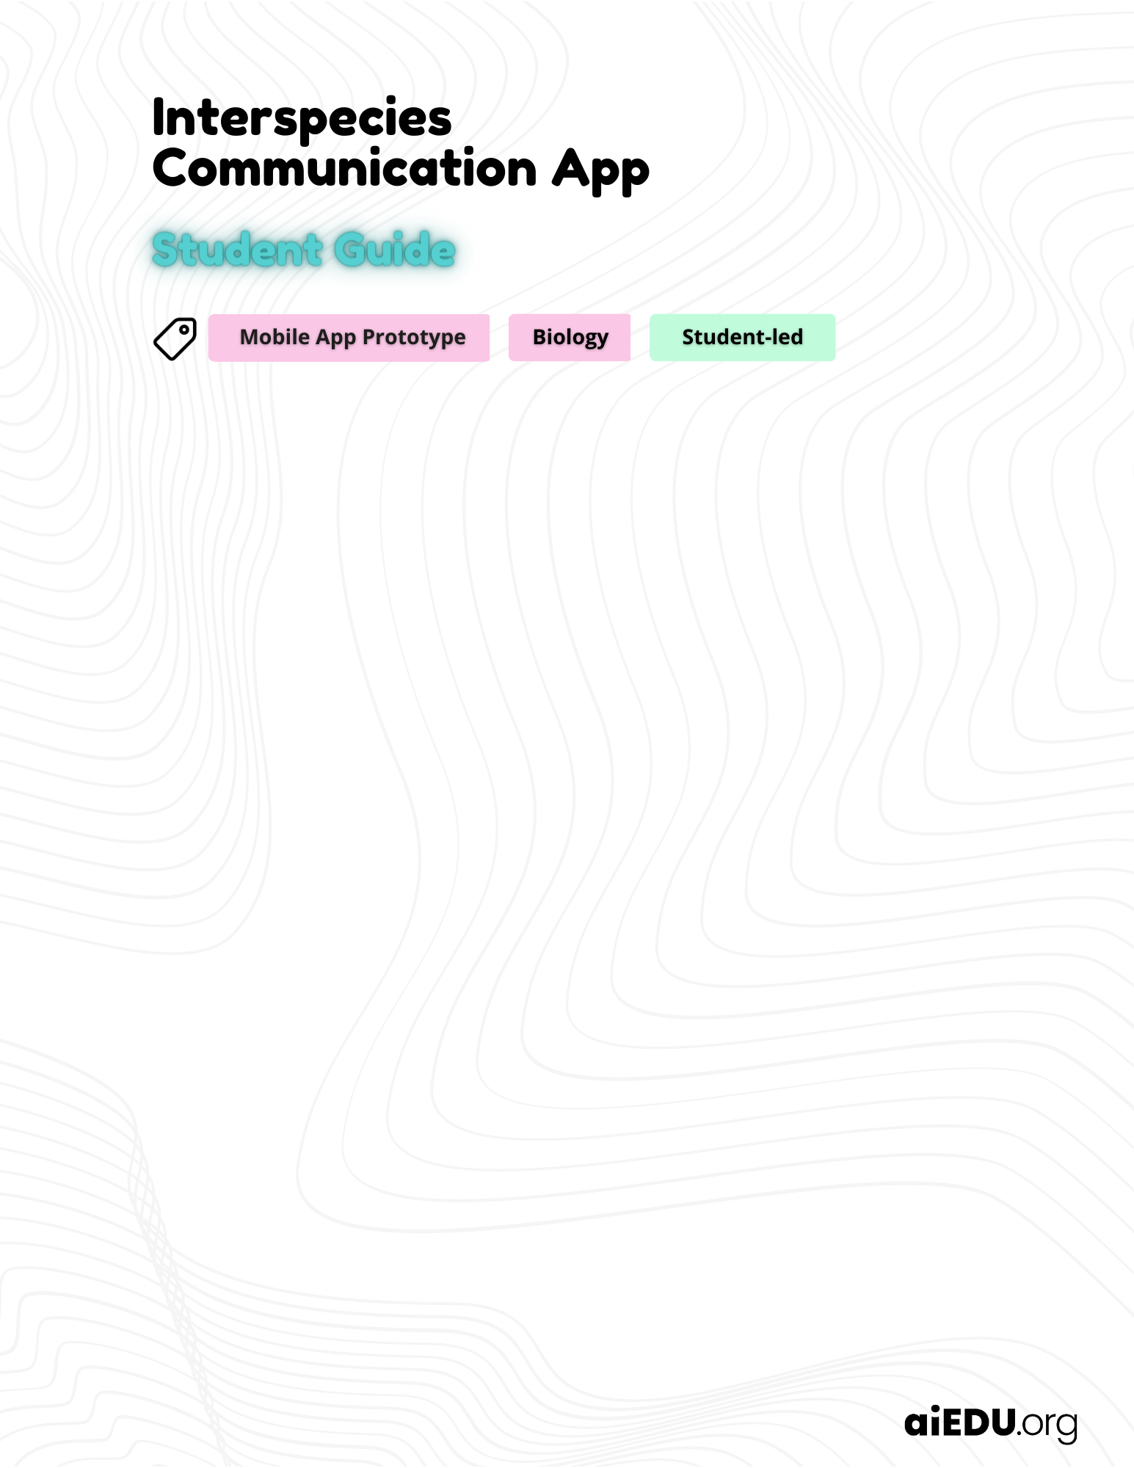

Add your answers in the green boxes below.

Animal talk superpower
 | Imagine you could talk to any animal in the world. Which animal would you choose and what would you say to it?

 | The definition of artificial intelligence (AI)
Check out the definition and interesting examples of AI at
🔗 aiedu.org/ai-in-five. Make sure to read the page before moving on.

How can AI be used to aid our understanding of how animals communicate with each other and with humans? Can you provide an example?

Need a hint? Visit the website 🔗 aiedu.org/ai-in-five to find some clues.

Decoding animal communication
The Earth Species Project (ESP)
The Earth Species Project is a group of researchers who are trying to crack the code of animal language. They use AI to analyze the sounds and movements that animals make and try to find patterns and meanings in them. They also use AI to separate different animal voices when they are talking at the same time, and to discover how animals behave in different situations.

Choose at least ONE of the ESP research projects to read about:
- 🔗 Understanding animal behavior with bio-logger data
- 🔗 Separating dolphin whistles from background noise

As you read, think about:
- What type of data is collected?
- How is the data collected?
- How is AI used to decode animal communication?

What is one type of data that the Earth Species Project uses to decode animal communication? How is the data collected?

How does the Earth Species Project use AI to decode animal communication?

Vocabulary Check
The definition of interspecies
Interspecies describes the interactions among different species in an ecosystem. These relationships can involve resource competition, such as fighting for food or shelter, or mutualistic cooperation, like bees pollinating flowers and receiving nectar in return.

The definition of interspecies communication
Interspecies communication is when animals of different species can communicate with each other using their own unique language. Communication can involve sounds, smells, or movements. It's kind of like when a pet owner and their furry friend have an unspoken understanding - they don't have to use words, but they can communicate through body language or eye contact.

🔗 Excited dog knows it’s time for a walk

In the above example, an excited doggo knows it’s time for a walk when they hear their human companion open-and-close their Apple EarPods case! This communication is made possible after many repetitions of the EarPods case closing followed by a walk.

Interspecies communication
Think about a time when you communicated with an animal using non-verbal cues like body language or eye contact. It could be a pet, a wild animal, or even an insect. Describe the situation and what you did to communicate with the animal.

Are you stuck? That’s ok! If you don't have a personal experience, search online for an example of “interspecies communication” and describe how it relates to the definition of interspecies communication.

Speculative AI
Interspecies communication app
In this project, you will design a mobile app that facilitates cooperative communication between different species. Embrace your creativity and delve into the world of speculative AI – envisioning ideas that may not exist today but could materialize with future AI advancements.

Brainstorm ideas
Brainstorm ideas for your mobile app
With more than 8.7 million different animal species on Earth, there are many opportunities for different species to work together and communicate in new and exciting ways.

Task
Brainstorm an idea for a mobile app that uses AI to facilitate communication between humans and non-human animals. Your app should be designed to help people connect with animals in a new and meaningful way. Consider the animals involved, the features that your app will include (such as location tracking, messaging, or other interactions), and the benefits of your app.

Directions
- Select the animals who will use your app. 🔗 Choose one non-human animal and one human animal from this list, or choose your own.
- Examine the potential benefits and limitations of facilitating interspecies communication with your app.
- Describe your app features.

Describe the animals that will use your app and the purpose of their communication within the app.

Benefits & Limitations
When you are designing a new mobile app, it's essential to think about the good things it can do, as well as any problems it might create. Take a look at the image below to see some of the ways an app that helps different species communicate may be helpful or not. Can you think of any other benefits or limitations?

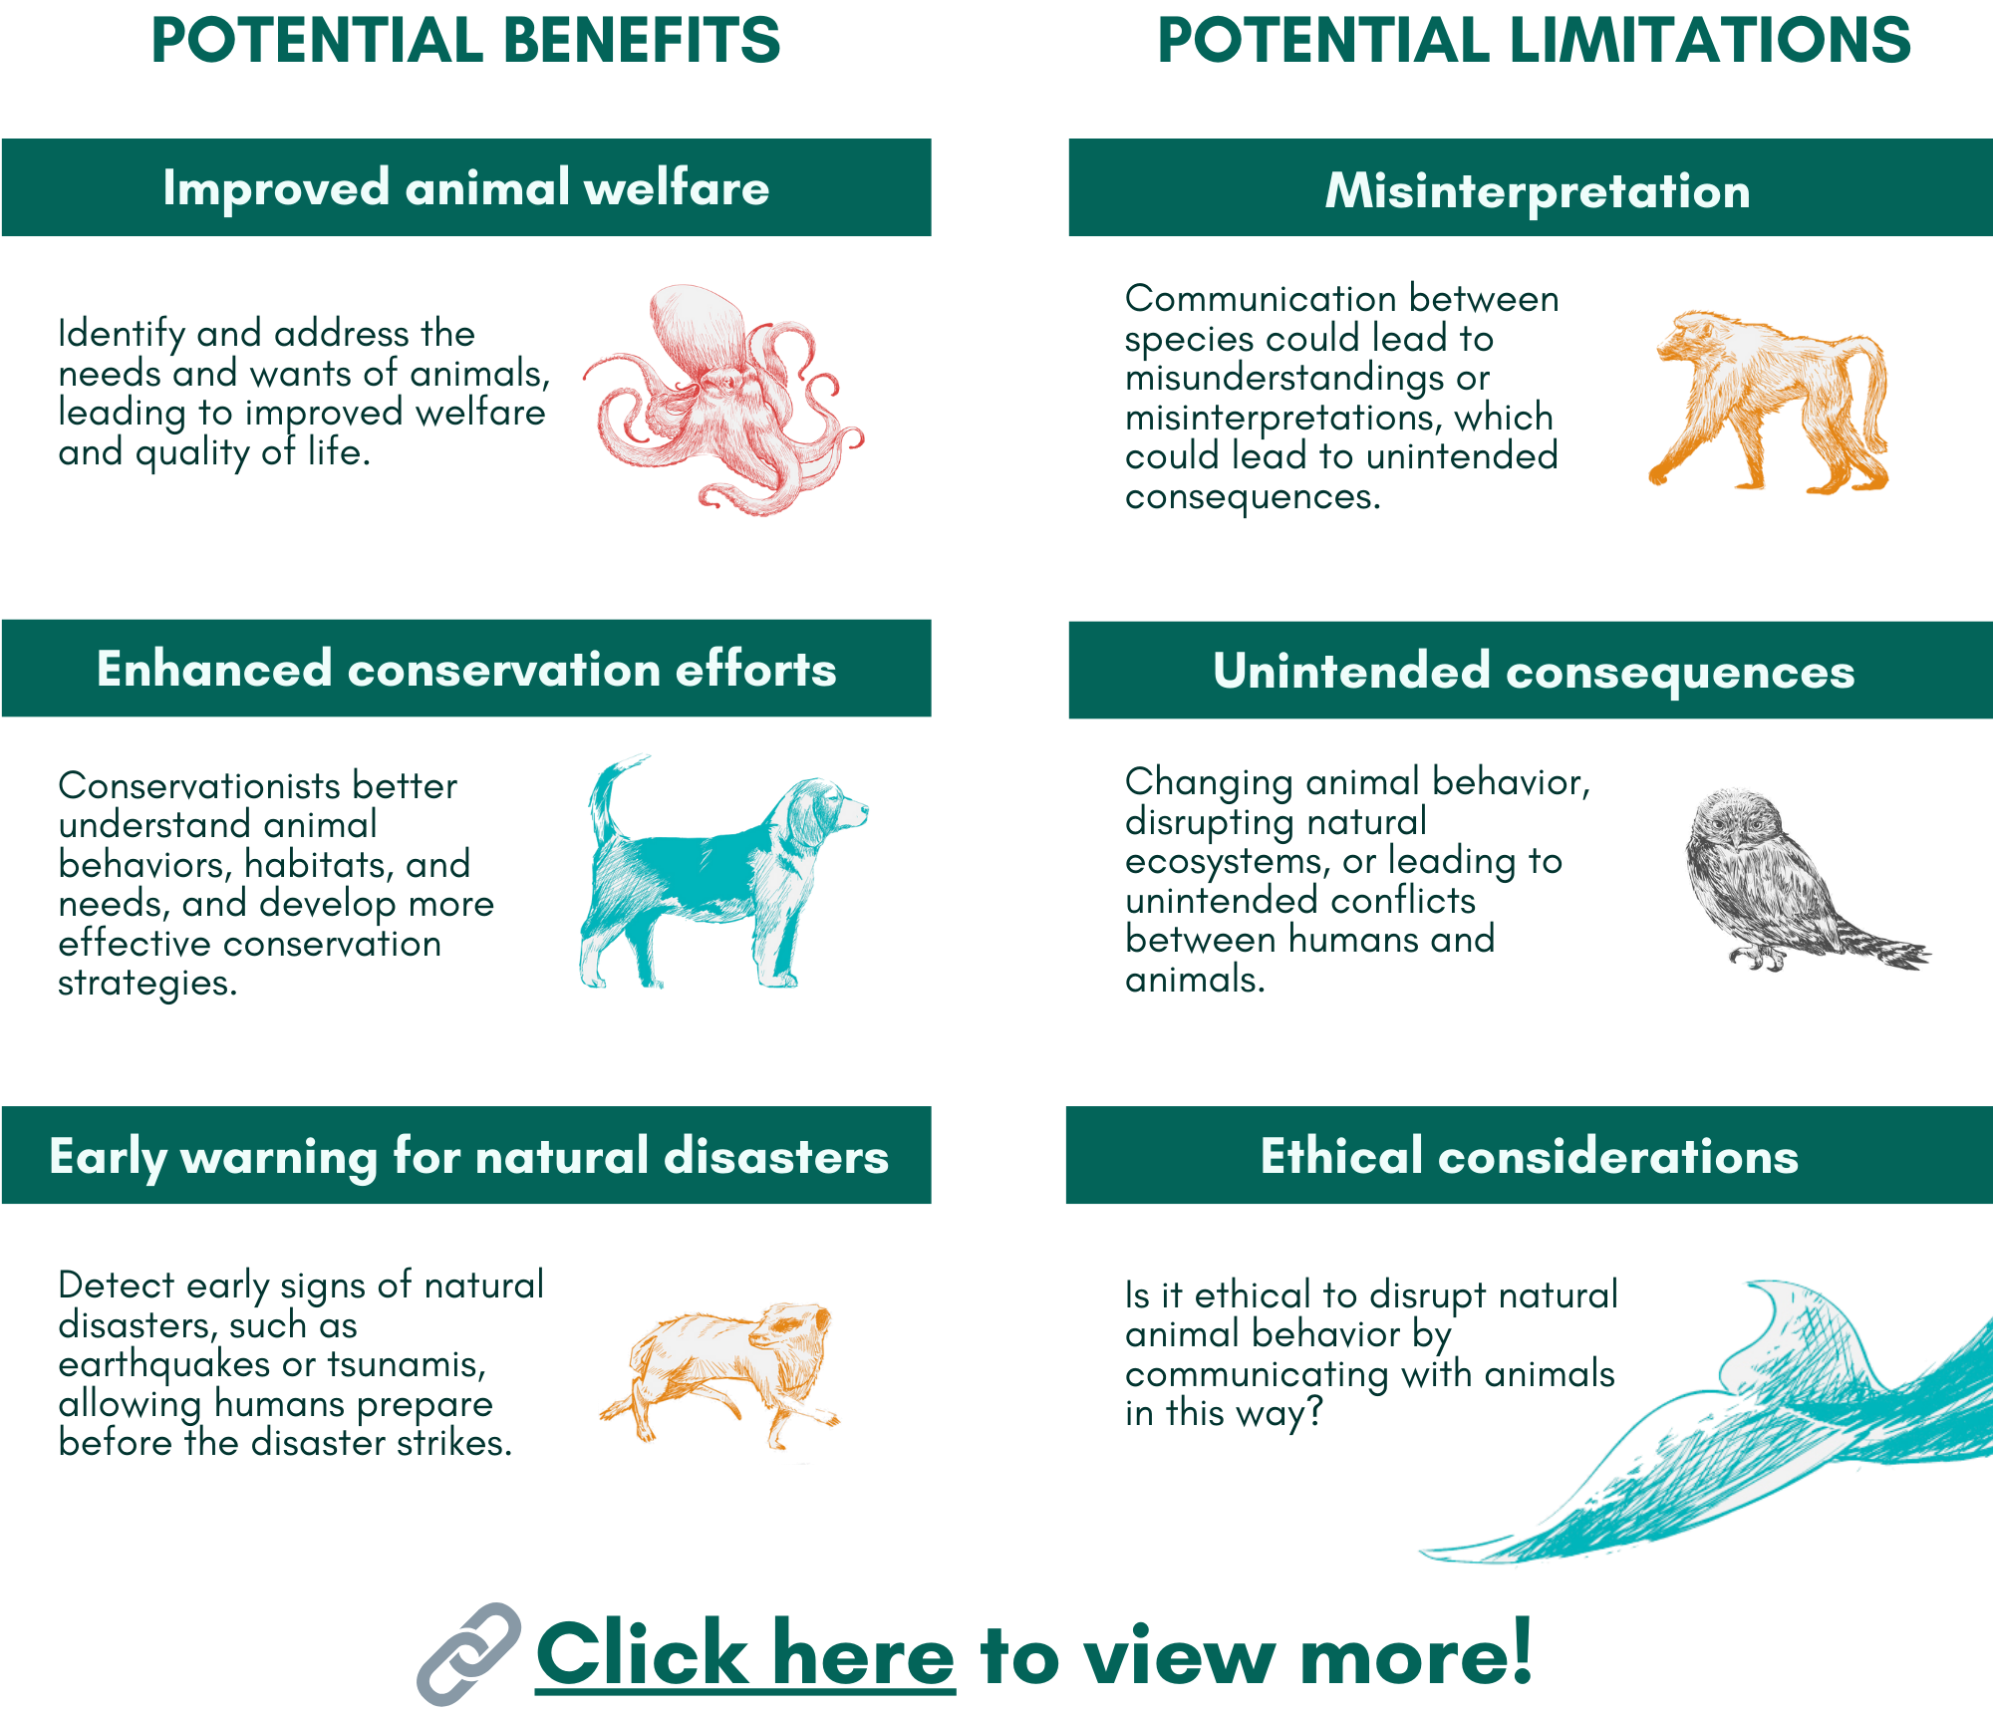

🔗 Click here to see the full size image plus additional benefits and limitations!

Share at least one benefit and one limitation related to your app idea.

Describe your app features, including details about how the animals involved will benefit from interspecies communication. Will they use the app to connect for play, research, support, or for some other purpose? Be creative and think outside the box when imagining the possible features for your app.

Create your mobile app prototype
Create your mobile app prototype
A mobile app prototype is like a draft version of a phone app that's created for demonstration purposes. It shows how the app will look and feel, and how users will interact with it.

Task
Create a mobile app prototype that demonstrates your idea for an interspecies communication scenario. Keep in mind that the AI-powered technology that's necessary for the app to function in the real world may not exist yet. That’s ok! This project is a speculative AI design exercise that offers us a glimpse into what the future might hold with advancements in AI technology.

Directions
- Review the slides in the 🔗 prototype overview. This is an important step to help you understand the app design process.
- Make a copy of the 🔗 template in Canva (login or sign up to use the Canva template).
- Customize the template to demonstrate your idea for an interspecies communication app.
- Share a link to your mobile app prototype in the green box below.

Helpful hint: 🔗 Click here to watch a Canva video demonstration.

Link your mobile app prototype below.

Helpful Hint: 🔗 How to share a link to your prototype

Get ready to pitch!
Write a pitch for your prototype
Using the following outline as a guide, write a pitch for your prototype in the green box below.

- Sentence 1 - Introduce the app: Begin by briefly introducing the name and purpose of your mobile app prototype, making sure to mention its focus on interspecies communication using AI.
- Sentence 2 - Highlight the key feature(s): Describe the most important or unique feature(s) of your app, emphasize how it facilitates communication between humans and animals.
- Sentence 3 - Showcase the benefits: Explain the main benefits of using your app, such as improving human-animal relationships, enhancing animal welfare, etc.
- (Optional) Sentence 4 - Call to action: End the pitch with a call to action that encourages potential users to support your app or learn more about it, fostering excitement and anticipation.

Share your pitch (3-4 sentences).

